**PRACTICAL NO: 02**

**AIM: Data Acquisition:**

**- Perform data acquisition using:**

**- USB Write Blocker + FTK Imager**

**STEP 1: Enable USB Write Block in Windows 10, 8 and 7 using registry**

**Press the Windows key + R to open the Run box. Type regedit and press Enter.**

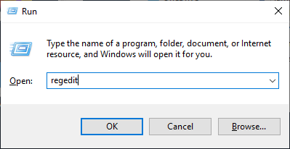

**STEP 2: This will open the Registry Editor. Navigate to the following key:**

**HKEY_LOCAL_MACHINE\SYSTEM\CurrentControlSet\Control\**

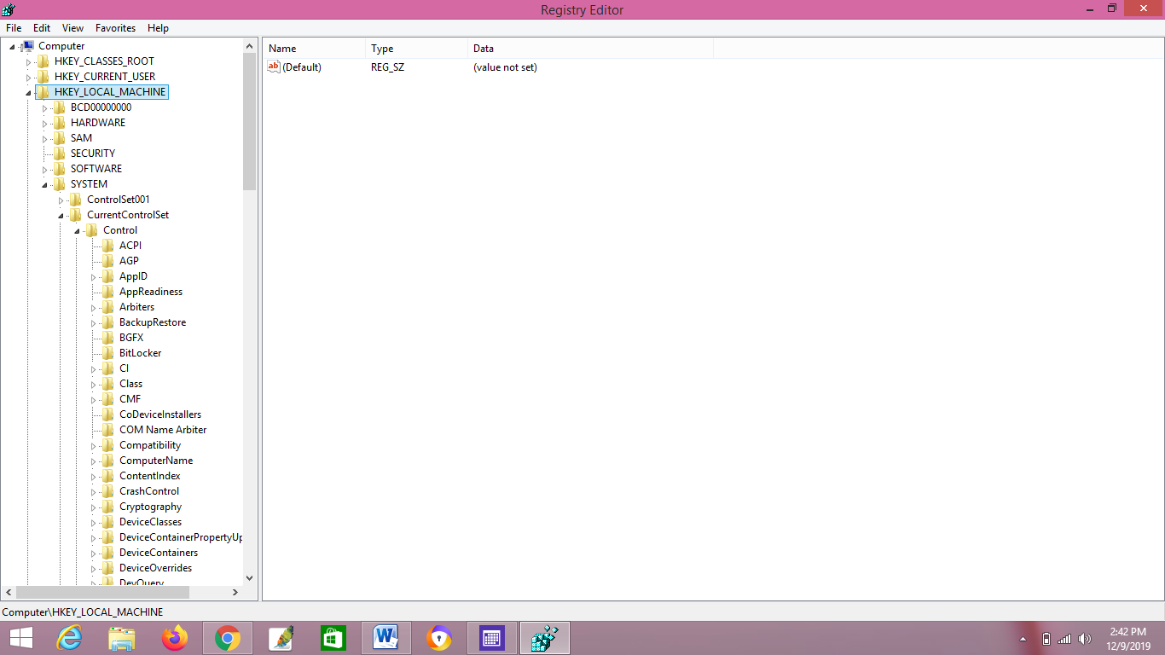

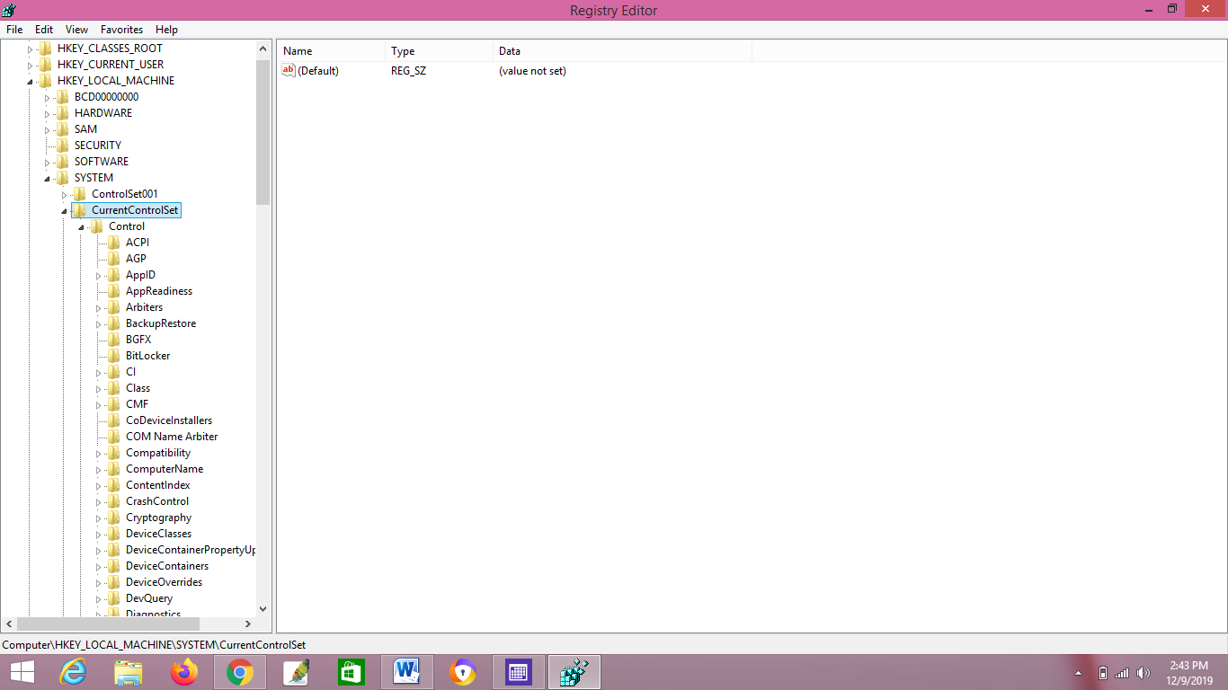

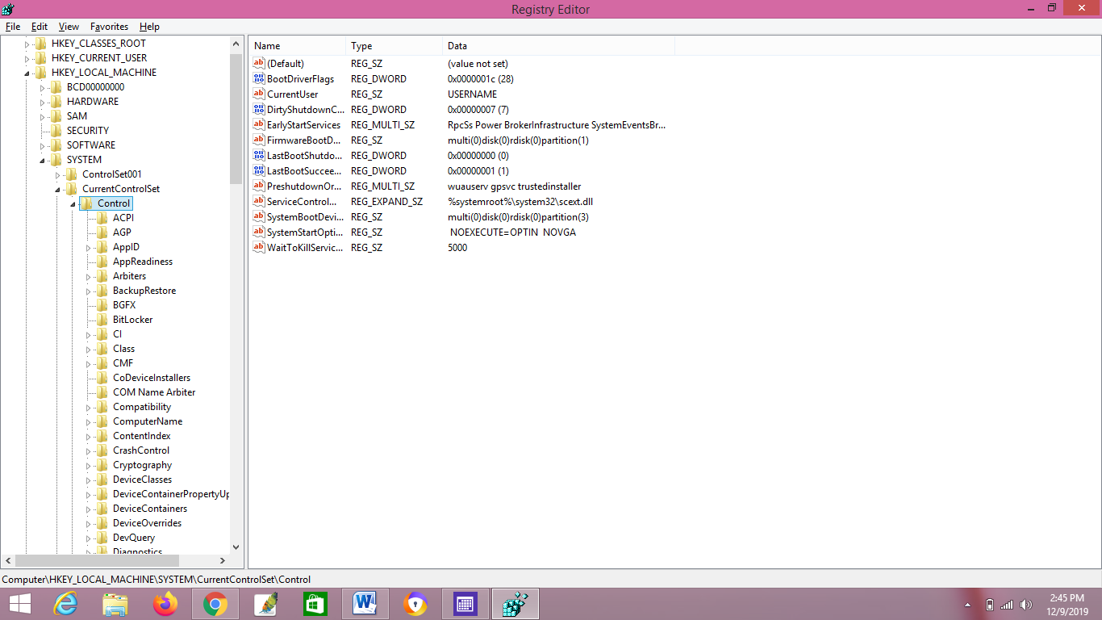

**STEP 3: Right-click on the Control key in the left pane, select New -> Key.**

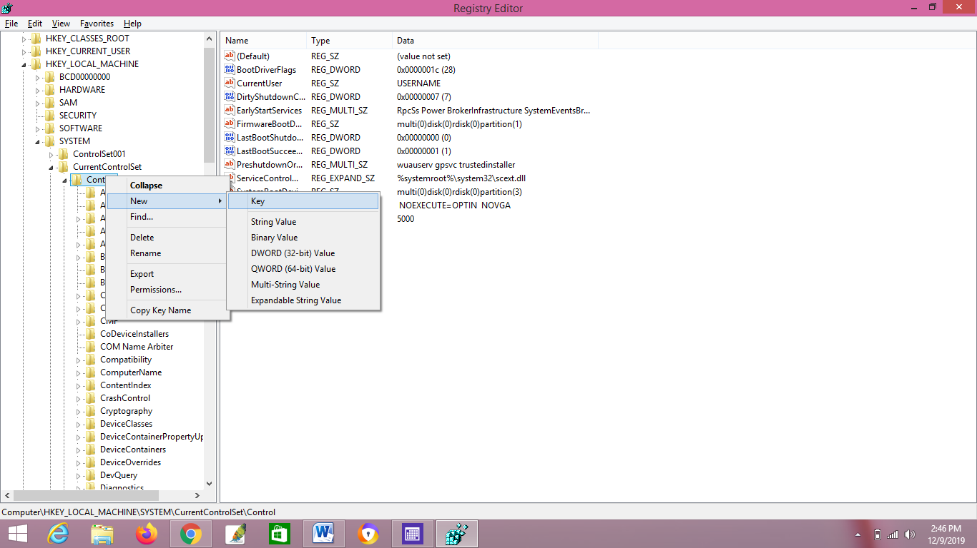

**STEP 4: Name it as StorageDevicePolicies.**



**STEP 5: Select the StorageDevicePolicies key in the left pane, then right-click on any empty space in the right pane and select New -> DWORD (32-bit) Value. Name it WriteProtect.**

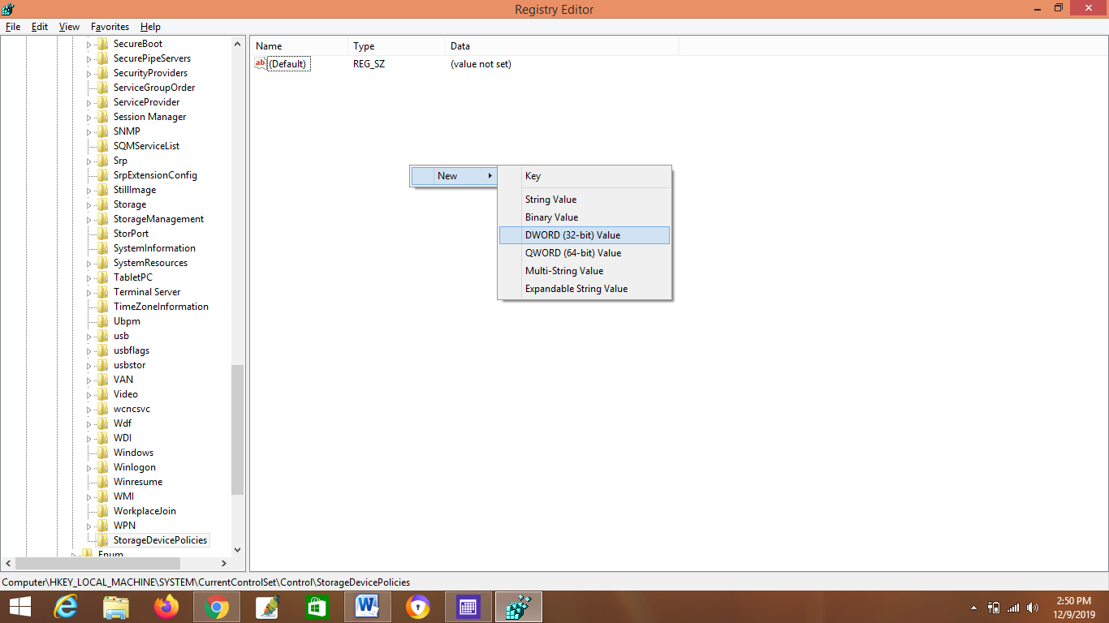

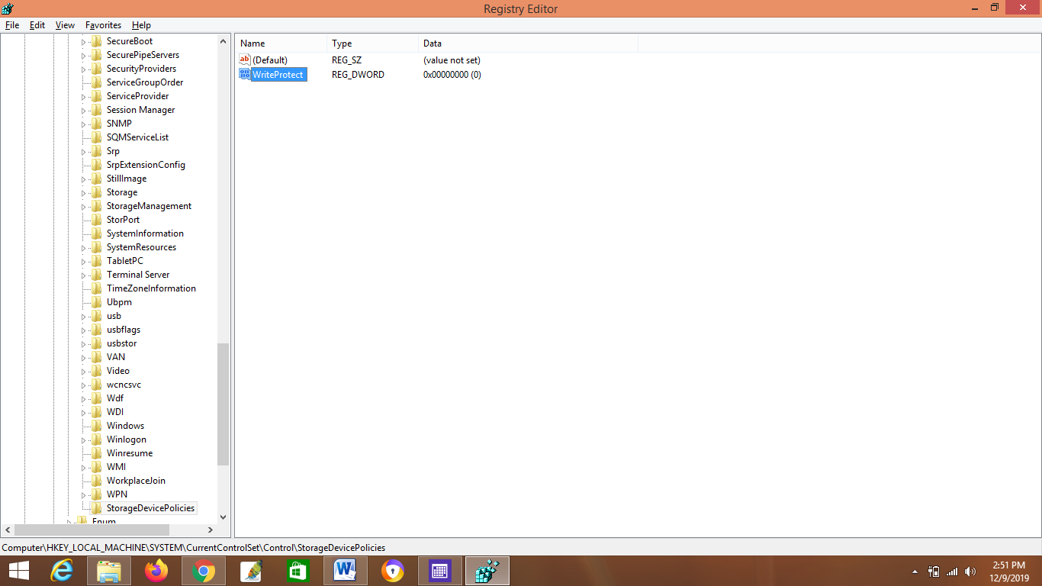

**STEP 6: Double-click on WriteProtect and then change the value data from 0 to 1.**

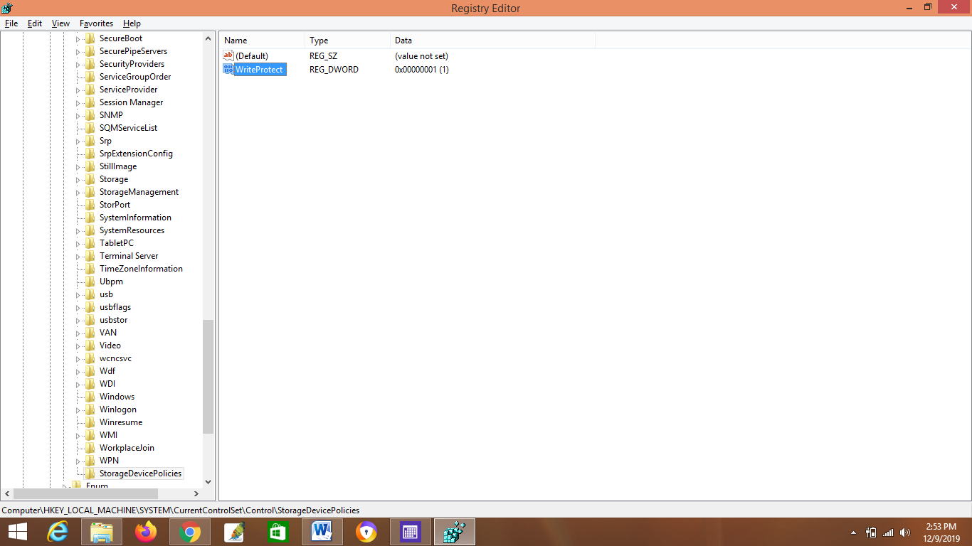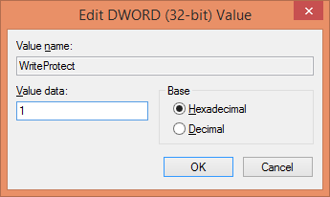

**STEP 7: The new setting takes effect immediately. Every user who tries to copy / move data to USB devices or format USB drive will get the error message “The disk is write-protected”.**

